**Unit 4 - Activity 4**

**Pairs of Forces Stations**

Adapted from AMTA ©2018

In the set of activities that follows, you will be asked to think about situations in which two objects interact. You should, in each case, think about the magnitude (amount) and direction of the forces that each object exerts on the other. You will be asked to make a prediction about the relative magnitudes of the forces each object exerts or experiences. For instance, if the situation involves two cars colliding, you might say that the force exerted on the small car by the large car is greater than the force exerted on the large car by the small car. Alternative possibilities are that the force on the small car by the large car is less than the force on large car by the small car. A third possibility is that the large car exerts the same force on the small car as the small car exerts on the large car. A convenient way to express such ideas is in the form of an inequality or an equation, using the agent-object notation that we have been using in our force diagrams. If the symbol L represents the large car and the symbol S represents the small car, the three possible predictions listed above could be represented as follows: FA by S on L > FA by L on S, FA by S on L < FA by L on S, or FA by S on L = FA by L on S. It is also possible that your answer depends on some condition. Predict what you think in each case, stating any required conditions for your prediction. Where graphs are produced, you should sketch the graph that appears on the screen, using the same color code as was used by the computer.

At each station, it is important that you understand that each of the objects involved in the interaction is a system. Each object will have a force sensor connected to it. The force sensor will indicate the force experienced by the object to which it is connected. If the sensor is connected to object A, and a force is exerted on object A by object B, the reading of that sensor is the force on object A by object B. Remember, the systems are the objects to which the sensors are connected, not the sensors themselves.

Another important experimental note is that the sensors are only able to read forces in one dimension. Make sure that the sensors are pushing or pulling on one another in a straight line along the axis of the sensor. It is also important to zero the sensors before each trial by clicking on the zero button. Make sure that the sensors are oriented in the same way they will be oriented when you perform the experiment, and that no forces are acting on the sensors when you zero them.

For a selected interaction at each station, you will draw a physical diagram of the situation. You should also draw two force diagrams; one for each object involved in the interaction. It is critical that you draw the arrows in your two force diagrams with the same scale in mind. It is equally important that you properly label each force diagram using the agent-object notation.

While you are performing each of the activities, you should be looking for an underlying “Big Idea” that ties the various activities together.

**Station 1 - Students Pushing on Each Other**



At this station, you and your partner will each hold a force probe. For each situation described below, predict how the force student A exerts on student B will compare to the force student B exerts on student A. You will then perform the action described and compare the actual result to your prediction. Once you have actually performed each experiment, sketch the graph shown by the computer of force vs. time. Plot the reading from force probe A in RED and force probe B in BLUE. Assume that the force probe held by student A indicates the force exerted on student A by student B and the force probe held by student B indicates the force exerted on student B by student A.

Your predictions can take the form of FA on B > FB on A, FA on B < FB on A, FA on B = FB on A, or some other description if you prefer.

Explain the reasoning behind your prediction and any conditions which are necessary for your prediction.

Include a physical diagram and a force diagram for situation **2** in the space to the right.

1. With a rubber stopper on the end of each force probe, student A should push on student B while student B passively holds the force probe.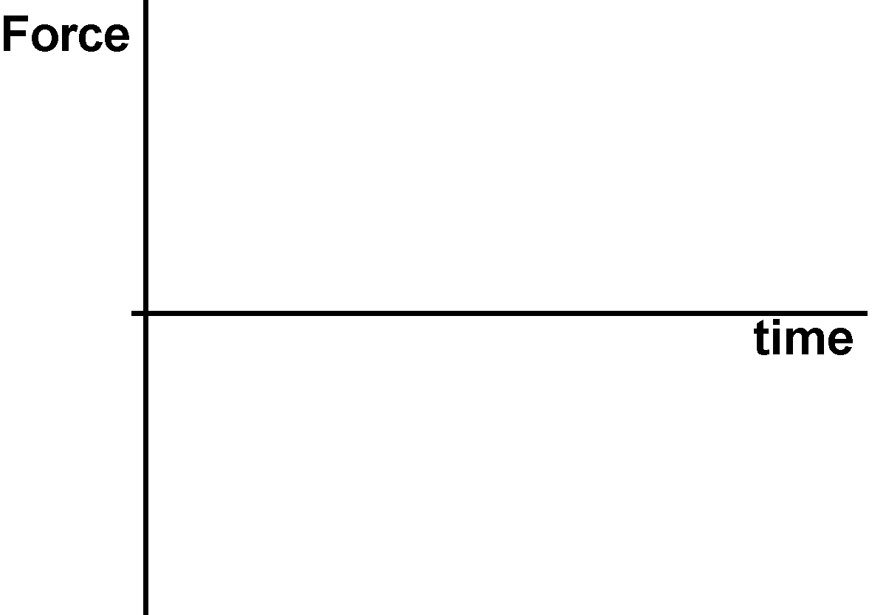

**Prediction:**

**Result:**

**2.** Student B should push on student A while student A passively holds the force probe.

**Prediction:**

**Result:**



3. Both students should push on each other.

**Prediction:**

**Result:**

**Station 2 - Students Pulling on Each Other**



At this station, you and your partner will each hold a force probe. For each situation described below, predict how the force student A exerts on student B will compare to the force student B exerts on student A. You will then perform the action described and compare the actual result to your prediction. Once you have actually performed each experiment, sketch the graph shown by the computer of force vs. time. Plot the reading from force probe A in RED and force probe B in BLUE. Assume that the force probe held by student A indicates the force exerted on student A by student B and the force probe held by student B indicates the force exerted on student B by student A.

Your predictions can take the form of

FA on B > FB on A, FA on B < FB on A, FA on B = FB on A, or some other description if you prefer.

Explain the reasoning behind your prediction and any conditions which are necessary for your prediction.

Include a physical diagram and a force diagram for situation **3** in the space to the right.

1. With a rubber band connecting the hooks on the force probes, student A should pull on student B while student B passively holds the force probe.

**Prediction:**

**Result:**



2. Using the same setup, student B should pull on student A while student A passively holds the force probe.

**Prediction:**

**Result:**



**3.** Both students should pull on each other.

**Prediction:**

**Result:**

**Station 3 - Cars Pushing Each Other on a Level Road**

Consider two cars, one of which is three times as massive as the other. In each 

situation, one of the cars should be thought of as being in neutral with the engine off. The second car should be considered to have the engine running and will push on the first. This situation will be modeled by having wooden blocks with different masses, and your hand will be the engine for the car that is doing the pushing. For each situation described below, predict how you think the force the large car exerts on the small car will compare to the force the small car exerts on the large car. You will then perform the action described and compare the actual result to your prediction. Once you have actually performed each experiment, sketch the graph shown by the computer of force vs. time. Plot the reading from force probe connected to the LARGE CAR in RED and force probe connected to the SMALL CAR in BLUE. Assume that the force attached to the large car indicates the force experienced by the large car, and the force probe connected to the small car indicated the force experienced by the small car. Your predictions can take the form of FL on S > FS on L, FL on S < FS on L, FL on S = FS on L, or some other description if you prefer. Feel free to explain your prediction.

Include a physical diagram and a force diagram for situation **4** in the space to the right.

1. Large car pushes small car at constant speed on level road.

**Prediction:**

**Result:**



2. Large car pushes small car while speeding up on level road.

**Prediction:**

**Result:**

3. Small car pushes big car at constant speed on level road.

**Prediction:**

**Result:**

**4.** Small car pushes big car while speeding up on level road.

**Prediction:**

**Result:**

**Station 4 - Cars Pushing Each Other on a Hill**



**The directions for Station 4 are the same as those for Station 3.**

Consider two cars, one of which is three times as massive as the other. In each

situation, one of the cars should be thought of as being in neutral with the engine off. The second car should be considered to have the engine running and will push on the first. This situation will be modeled by having wooden blocks with different masses, and your hand will be the engine for the car that is doing the pushing. For each situation described below, predict how you think the force the large car exerts on the small car will compare to the force the small car exerts on the large car. You will then perform the action described and compare the actual result to your prediction. Once you have actually performed each experiment, sketch the graph shown by the computer of force vs. time. Plot the reading from force probe connected to the LARGE CAR in RED and force probe connected to the SMALL CAR in BLUE. Assume that the force attached to the large car indicates the force experienced by the large car, and the force probe connected to the small car indicated the force experienced by the small car. Your predictions can take the form of FL on S > FS on L, FL on S < FS on L, FL on S = FS on L, or some other description if you prefer. Feel free to explain your prediction.

Include a physical diagram and a force diagram for situation **2** in the space to the right.

1. Small car pushes large car up the hill at constant speed.

**Prediction:**

**Result:**



**2.** Large car pushes small car up the hill at constant speed.

**Prediction:**

**Result:**



3. Small car pushes large car down the hill at constant speed.

**Prediction:**

**Result:**

4. Large car pushes small car down the hill at constant speed.

**Prediction:**

**Result:**

**Station 5 - Cars Towing Each Other on a Level Road**

Consider two cars, one of which is three times as massive as the other. In each situation, 

one of the cars should be thought of as being in neutral with the engine off. The second car should be considered to have the engine running and will tow the first. This situation will be modeled by having wooden blocks with different masses, and your hand will be the engine for the car that is doing the towing. For each situation described below, predict how you think the force the large car exerts on the small car will compare to the force the small car exerts on the large car. You will then perform the action described and compare the actual result to your prediction. Once you have actually performed each experiment, sketch the graph shown by the computer of force vs. time. Plot the reading from force probe connected to the LARGE CAR in RED and force probe connected to the SMALL CAR in BLUE. Assume that the force attached to the large car indicates the force experienced by the large car, and the force probe connected to the small car indicated the force experienced by the small car. Your predictions can take the form of FL on S > FS on L, FL on S < FS on L, FL on S = FS on L, or some other description if you prefer. Feel free to explain your prediction.

Include a physical diagram and a force diagram for situation **1** in the space to the right.



**1.** Large car tows small car at constant speed.

**Prediction:**

**Result:**

2. Large car tows small car while speeding up.

**Prediction:**

**Result:**

3. Small car tows big car at constant speed.

**Prediction:**

**Result:**

4. Small car tows big car while speeding up.

**Prediction:**

**Result:**

**Station 6 - Cars Towing Each Other on a Hill**



**The directions for Station 6 are the same as those for Station 5.**

Consider two cars, one of which is three times as massive as the other. In each situation,

one of the cars should be thought of as being in neutral with the engine off. The second car should be considered to have the engine running and will tow the first. This situation will be modeled by having wooden blocks with different masses, and your hand will be the engine for the car that is doing the towing. For each situation described below, predict how you think the force the large car exerts on the small car will compare to the force the small car exerts on the large car. You will then perform the action described and compare the actual result to your prediction. Once you have actually performed each experiment, sketch the graph shown by the computer of force vs. time. Plot the reading from force probe connected to the LARGE CAR in RED and force probe connected to the SMALL CAR in BLUE. Assume that the force attached to the large car indicates the force experienced by the large car, and the force probe connected to the small car indicated the force experienced by the small car. Your predictions can take the form of FL on S > FS on L, FL on S < FS on L, FL on S = FS on L, or some other description if you prefer. Feel free to explain your prediction.

Include a physical diagram and a force diagram for situation **3** in the space to the right.

1. Small car tows large car up the hill at constant speed.

**Prediction:**

**Result:**



2. Large car tows small car up the hill at constant speed.

**Prediction:**

**Result:**



**3.** Small car tows large car up the hill at increasing speed.

**Prediction:**

**Result:**

4. Large car tows small car up the hill at increasing speed.

**Prediction:**

**Result:**

**Station 7 – Equal Mass Carts Colliding**

Consider two carts of equal mass. In each situation, the carts will collide according to the description below. In each case, one of the carts has a spring bumper and the other has a rubber bumper. It is important that the carts stay on the track during the collision. If the carts move too fast, they will be derailed from the track and your force measurements will be inaccurate, so make the collisions reasonably gentle. Create each of the collisions below and compare the actual result to your prediction. Once you have actually performed each experiment, sketch the graph shown by the computer of force vs. time. Plot the reading from force probe connected to the CART A in RED and force probe connected to the CART B in BLUE. Assume that the force probe attached to cart A indicates the force exerted on cart A by cart B, and the force probe connected to cart B indicates the force exerted on cart B by cart A.

Your predictions can take the form of FA on B > FB on A, FA on B < FB on A, FA on B = FB on A, or some other description if you prefer. Feel free to explain your prediction.

Include a physical diagram and a force diagram for situation **1** in the space to the right.

**1.** Cart collides with an identical second cart which is initially at rest.

**Prediction:**

**Result:**



2. Two identical carts with equal speeds have a head-on collision.

**Prediction:**

**Result:**



3. Slow cart collides with faster cart.

**Prediction:**

**Result:**

**Station 8 – Different Mass Carts Colliding**

Consider two carts of different mass. In each situation, the carts will collide according to 

the description below. In each case, one of the carts has a spring bumper and the other has a rubber bumper. It is important that the carts stay on the track during the collision. If the carts move too fast, they will be derailed from the track and your force measurements will be inaccurate, so make the collisions reasonably gentle. Create each of the collisions below and compare the actual result to your prediction. Once you have actually performed each experiment, sketch the graph shown by the computer of force vs. time. Plot the reading from force probe connected to the LOW MASS CART in RED and force probe connected to the HIGH MASS in BLUE. Assume that the force probe attached to the low mass indicates the force exerted on the low mass cart by the high mass cart, and the force probe connected to high mass cart indicates the force exerted on the high mass cart by the low mass cart.

Your predictions can take the form of FL on H > FH on L, FL on H < FH on L, FL on H = FH on L, or some other description if you prefer. Feel free to explain your prediction.

Include a physical diagram and a force diagram for situation **3** in the space to the right.

1. Low mass cart collides with a more massive cart which is initially at rest.

**Prediction:**

**Result:**

2. Large mass cart collides with a small mass cart which is initially at rest.

**Prediction:**

**Result:**

**3.** Large mass cart collides with a small mass cart when both are moving toward each other at the equal speeds.

**Prediction:**

**Result:**

**Station 9 - Forces on Carts**

Consider two students on low friction carts able to push on each other while holding force plates. Consider the force that each student exerts on the other during the interaction. What motion results in each case? Does the force depend on the mass of the students? Does the motion depend on the mass of the students? For each situation described below, predict how the force student A exerts on student B will compare to the force student B exerts on student A. You will then perform the action described and compare the actual result to your prediction. Once you have actually performed each experiment, sketch the graph shown by the computer of force vs. time. Plot the reading from force plate A in RED and force plate B in BLUE. Assume that the force plate held by student A indicates the force on student A by student B and that the force plate held by student B indicates the force on student B by student A. Your predictions can take the form of FA on B > FB on A, FA on B < FB on A, FA on B = FB on A, or some other description if you prefer.

Explain the reasoning behind your prediction and any conditions which are necessary for your prediction.

Include a physical diagram and a force diagram for situation

**3** in the space to the right.

1. Student A sits on a cart. Student B sits on a cart. Student A should push on student B with a force place while student B holds another force plate. How do the forces compare? What motion do you expect for each student? What motion actually occurs?

**Prediction:**

**Result:**

2. Student A sits on a cart. Student B sits on a cart. Student A should push on student B while student A holds a force plate. How do the forces compare? What motion do you expect for each student? What motion actually occurs?

**Prediction:**

**Result:**

**3.** Both students should push on each other with the force plates. How does the force exerted on student A by student B compare to the force exerted on student B by student A? Does your answer depend on the mass of each student? What motion do you expect for each student? What motion actually occurs?

**Prediction:**

**Result:**

**Station 10 - Forces on Carts 2**

Consider two students, one on a low friction carts and another standing on the ground. Each student holds a force plate. Consider the force that each student exerts on the other during the interaction. Does the force depend on the mass of the students? For each situation described below, predict how the force student A exerts on student B will compare to the force student B exerts on student A. You will then perform the action described and compare the actual result to your prediction. Once you have actually performed each experiment, sketch the graph shown by the computer of force vs. time. Plot the reading from force plate A in RED and force plate B in BLUE. Assume that the force plate held by student A indicates the force on student A by student B and that the force plate held by student B indicates the force on student B by student A. Your predictions can take the form of FA on B > FB on A, FA on B < FB on A, FA on B = FA on B, or some other description if you prefer. 

Explain the reasoning behind your prediction and any conditions which are necessary for your prediction. Include a force diagram for each of the students in each situation.

Include a physical diagram and a force diagram for situation **3** in the space to the right.



1. Student A sits on a cart. Student B stands on the ground. Student B should push on student 1 with a force place while student 1 holds another force plate. A third student prevents the cart from moving. How do the forces compare?

**Prediction:**

**Result:**

2. Student A sits on a cart. Student B stands on the ground. Student B should push on student A with a force place while student A holds another force plate so that the cart moves at a constant speed. How do the forces compare?

**Prediction:**

**Result:**

**3.** Student A sits on a cart. Student B stands on the ground. Student B should push on student A with a force place while student B holds another force plate so that the cart moves at an increasing speed. How do the forces compare?

**Prediction:**

**Result:**



4. Student ‘A sits on a moving cart. Student B stands on the ground. Student B should push on student A with a force place while student A holds another force plate so that the cart moves at an decreasing speed. How do the forces compare?

**Prediction:**

**Result:**